INTRODUCTION:
I have worked on a project which is similar to the dinosaur game of chrome. But it isn’t the exact simulation. The goal is to create a bot that is able to play the game with the best score.

About simulation environment:

- The simulation window size is 800x800, the player(dinosaur) is represented by a red block and the obstacle is represented by a blue block which moves from right to left on the screen.
- The cactus speed is initially at 5 units and is increased by 0.001 unit per frame of simulation.
- When the dinosaur receives a command to jump it goes to 200 height max then comes back to 0 with a rate of 5 units.
- A new cactus is spawned when the previous one goes out of screen at a distance of 800 + Cactus.speed*200/5.
- When a collision is detected the game is over for the given player.

About agents:

Agents’ goal is to survive for 200 seconds.
The agents take input precepts as the speed of cactus and the distance from it then calculate a value ‘y’ with a linear equation
y = g1*speed + g2*dist + g3
Where {g1, g2, g3} are the genes of the bot which are used in the above linear equation to calculate the y and make a decision.
When y is greater than a constant (here taken as 2) it commands the bot to jump.

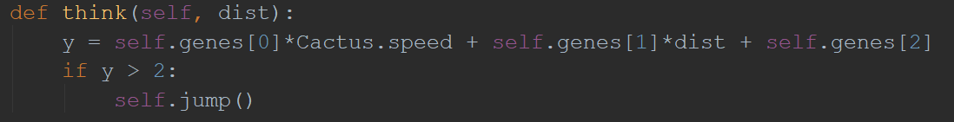

Approach:
First I played the game a bit to collect and visualize the data (speed and distance)
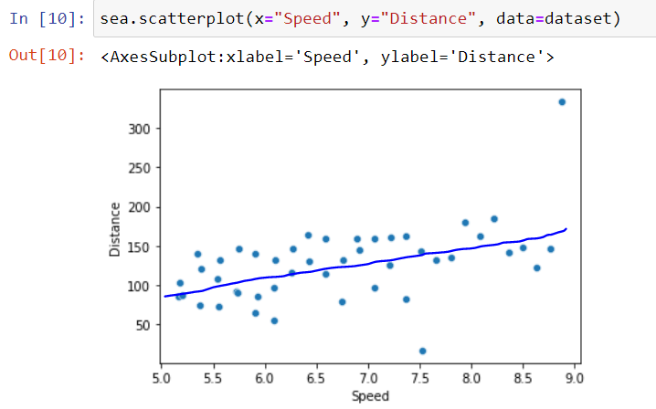
This data shows that there does lie a linear relation (somewhere near the blue line), therefore, a linear equation is used in the think() function

Now to find the coefficient and intercept (genes of the bot) for the line genetic algorithm approach is used.

Genetic Algorithm Implementation:
The implementation has components:

Populate: returns the list of genes to be assigned to the bots
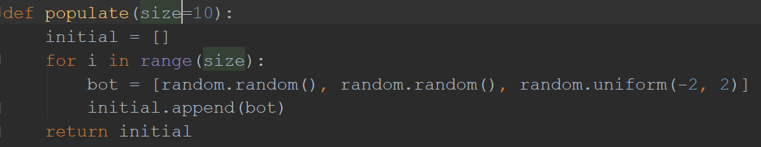

Reproduce: Instead of sexual reproduction, the chosen bots are cloned and the clones (no crossover part) are introduced with mutation ‘x’ (-MaxStepSize<x< MaxStepSize (here alpha))
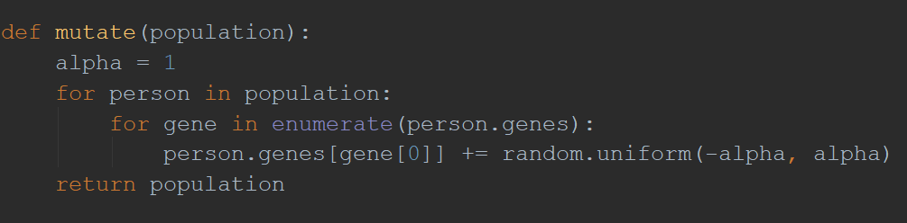

Fitness function (scoring):
Three scoring formulas were tested,
secondsSurvived: caused the bots to just jump all the time instead of
jumping only when needed
secondsSurvived - jumps*10: as it imposed heavy penalty on jumps, the
the bots decided to not jump at all
secondsSurvived - jumps/secondsSurvived: It provides a +ve score while mildly penalizing the jump action to promote jumping only when needed.
This system is used in the project.

Selection: the population is sorted according to their scores(ascending) and the bottom half of the population size(here 8) is selected to clone (ranked selection).

Results:
The avg score of the gen and the best of the said gen for
maxStepSize of 0.2, 0.5, 0.7, 1 (here alpha).
Avg=x is the avg of the time survived of all the bots(16) in that generation for alpha=x.
Best(x) is the time survived by the last dying bot in that generation for alpha=x..

For alpha = 0.2
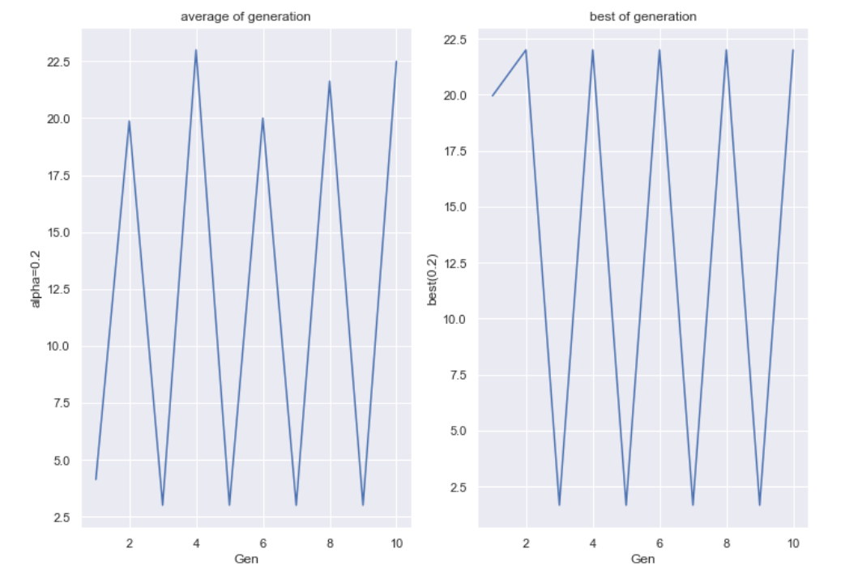

For alpha = 0.5

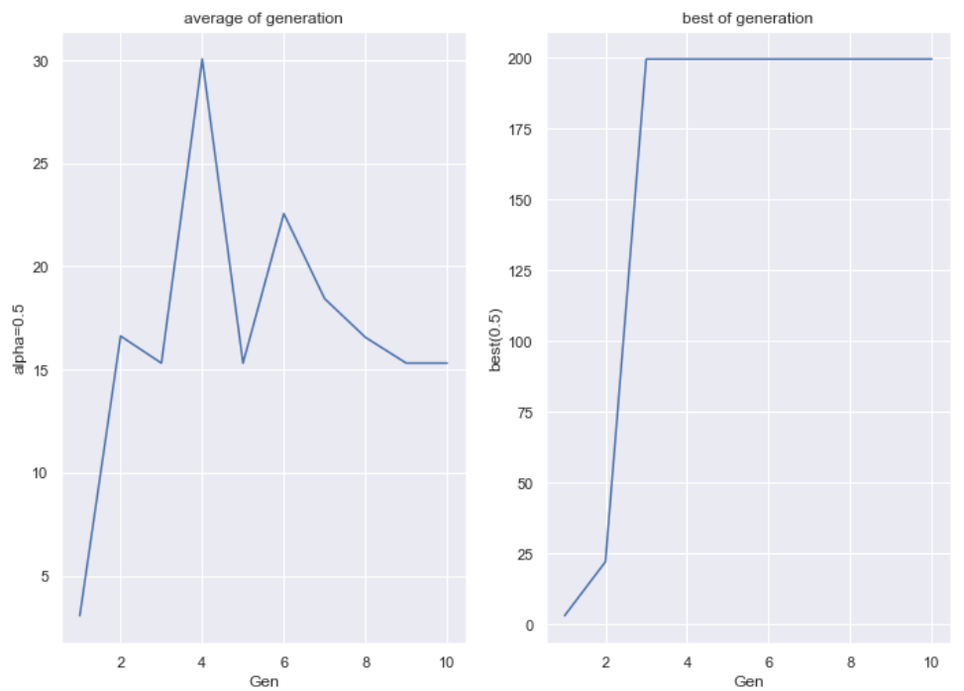

For alpha = 0.7 (best selection from the list):

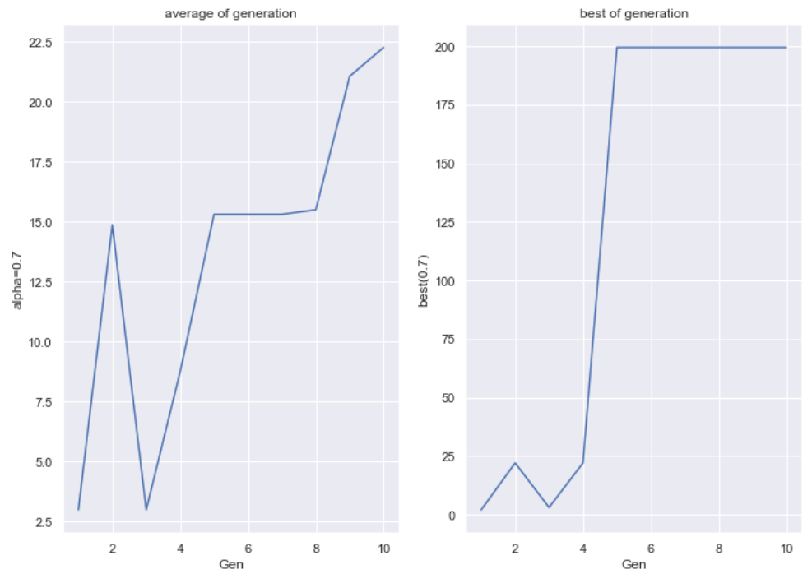
Video of 10th generation for alpha = 0.7 is attached with the mail

For alpha = 1:



